**TASK 1**

**Step 1: Create a Hosted Zone in Route 53**

1. Go to AWS Console → **Route 53**
2. Click **Hosted Zones → Create Hosted Zone**
3. Enter your domain name
4. Type: **Public Hosted Zone**
5. Click **Create**

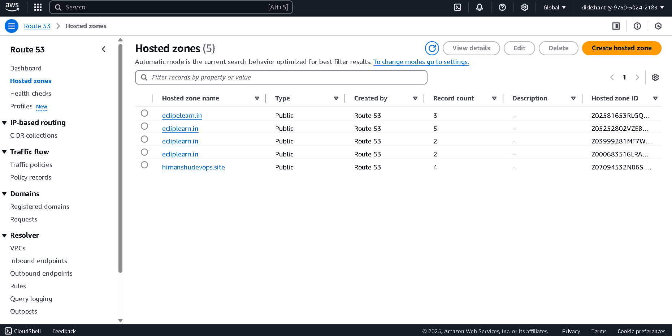

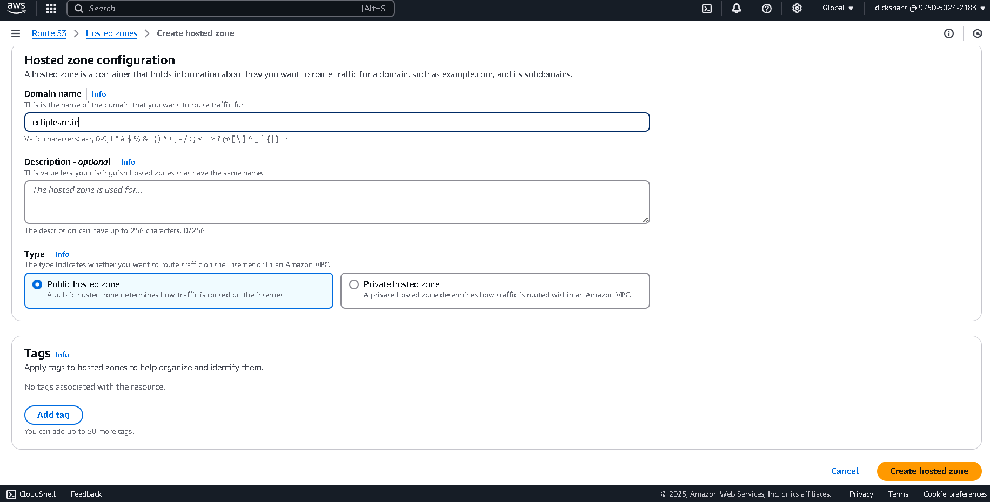

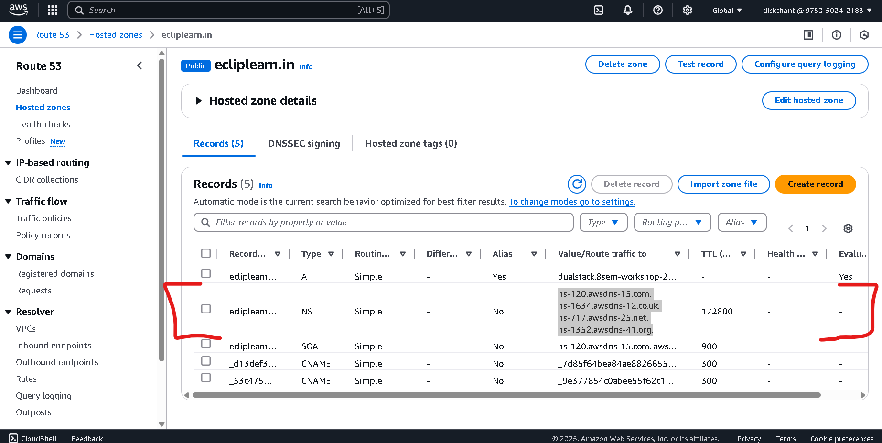

**Step 2: Launch and Configure EC2 Instance**

1. Go to AWS Console → **EC2 → Launch Instance**
2. Choose Ubuntu
3. Instance type: t3.micro
4. Key Pair: Create or use an existing key
5. Configure:
   * Network: Choose existing VPC and subnet
   * Security Group: Allow **Ports 22 (SSH), 80, 8080 (for Jenkins)**
6. Launch the instance

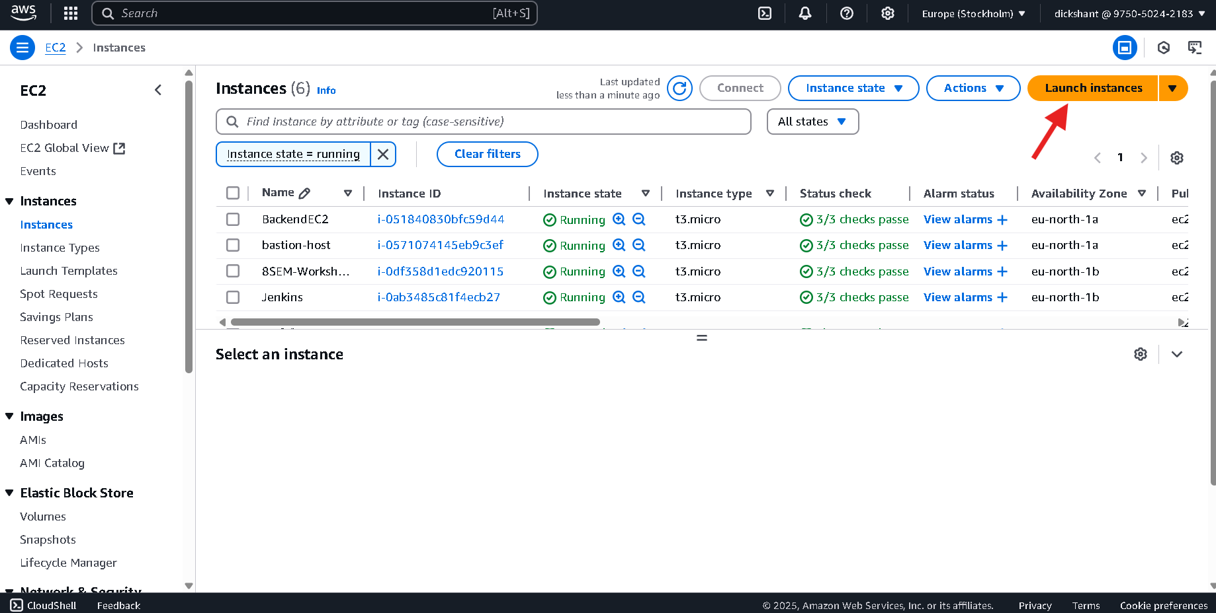

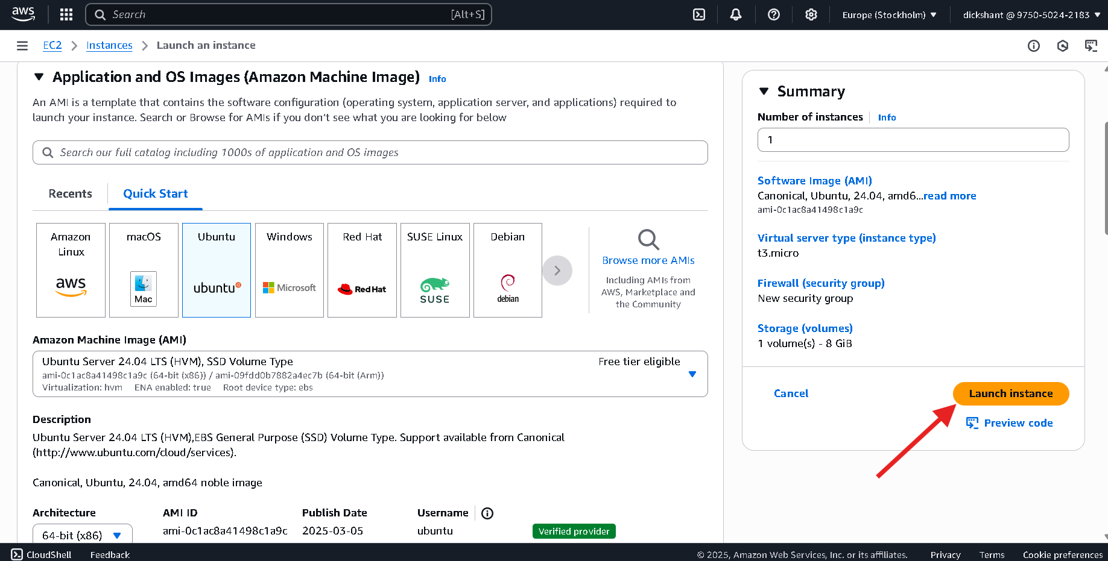

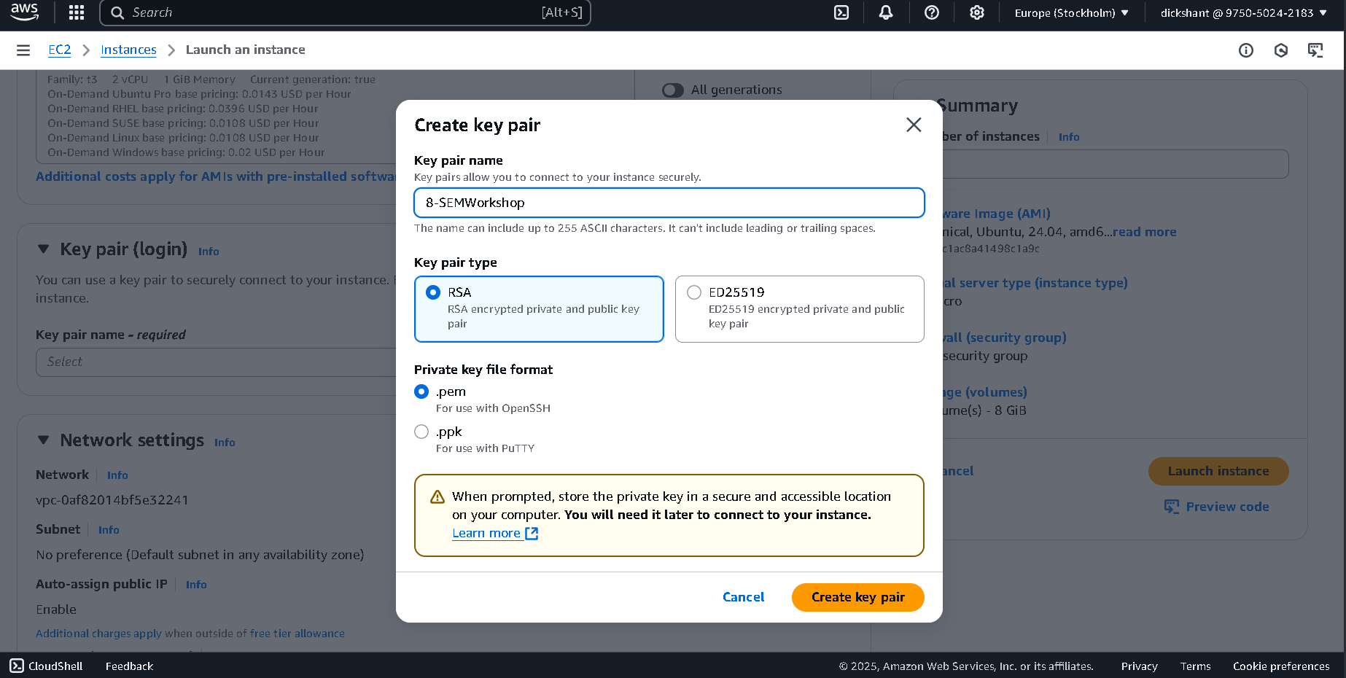

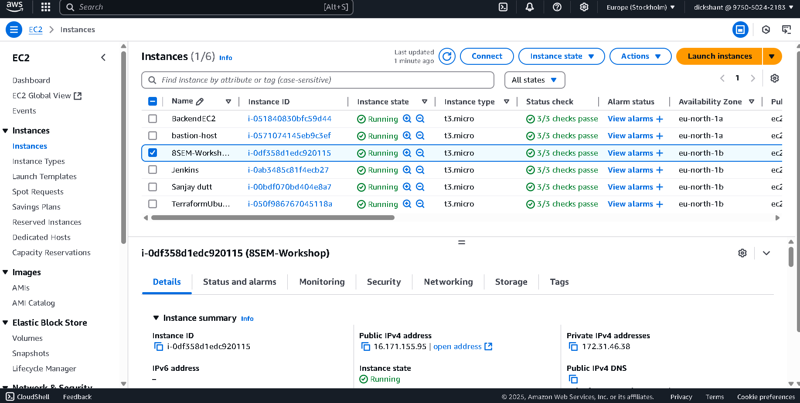

**Step 3: Install Jenkins on EC2**

1. sudo apt update
2. sudo apt upgrade -y
3. sudo apt install openjdk-17-jdk -y
4. java -version
5. **Add Jenkins GPG Key and Repository:**curl -fsSL https://pkg.jenkins.io/debianstable/jenkins.io2023.key | sudo tee \ /usr/share/keyrings/jenkins-keyring.asc > /dev/null

echo deb [signed-by=/usr/share/keyrings/jenkins-keyring.asc] \

https://pkg.jenkins.io/debian-stable binary/ | sudo tee \ /etc/apt/sources.list.d/jenkins.list > /dev/null

1. sudo apt update
2. sudo apt install jenkins -y
3. sudo systemctl start jenkins
4. sudo systemctl enable jenkins

* **Result:**

Visit <http://16.171.155.95:8080> to access Jenkins

